**MyDairy App**

1. **Introduction to MyDairyProject:**

The My Dairy project is “A collection of notes from your life”. The main aim of this project is, one can write their day to day life works, store their memories with dates. Can write anything and can delete their memories or tasks if it is not necessary.

In this project the notes will be saved based on files, and Database,and file note can be view, update and delete.

So on clicking on save button the note will be saved using files and and onclicking on same save button and by taking date from date picker the notes will be saved using database

That is files and database of notes will be saved at a time.

Date for saved notes with files displays default and date for database should taken from date picker. Without taking date the date of notes database displays nothing

2. **Concepts**

* activity
* Intent
* Menu
* Dialogs
* Database

2. **Layouts of projects:**

a. activity_main.xml : Contains listview to display all saved notes which are written in activity_dairy.xml

b. activity_diary.xml : 2 EditTexts for title, and content after pressing create menu item button we can write our note in this.

c. view_diary_item.xml : This layout xml is for doing design for all saved notes which gets displayed in activity_main.xml which contains 3 Text Views for Title , Creation DateTime of note , and Content of note

d.activity_date_picker_fragment : This layout is for displaying textview in the form of fragment so taken balnk text view

e.content_note_list : This layout is for displaying db notes in the form of list view so taken list view in this layout

d.view_db_dairy_data: This layout xml is for doing design for all saved DB notes which gets displays ,which contains 3 Text Views for Title , Creation DBDate of note , and Content of note

3. **Working of Project**:

a. **Dairy.java** : This class represents all dairy objects implementing serializable interface and using proper getters and setters.And added variables and empty Dairy constructor

b. **MainActivity.java**: This is the launcher activity , this class helps to displays all saved notes in the form of listviews which are created by clicking create button in activity_main.xml and goes to activity_dairy.xml to write notes and comes back to main activity layout by using this class.

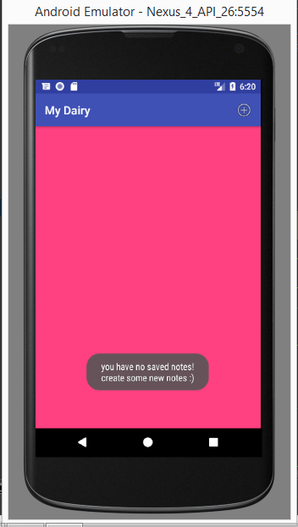

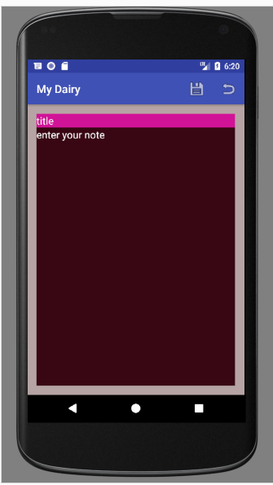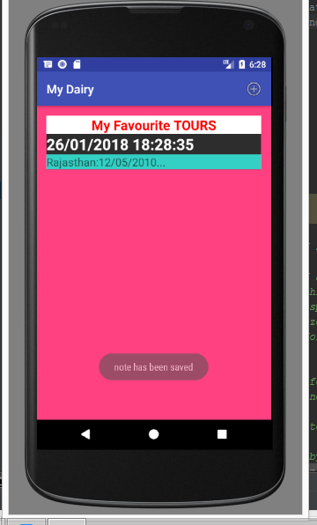

**First Image**: Main Activity with no saved notes by clicking on add button on tool bar it goes to activity_diary.xml

to create a new note

**Second Image**: starts creating new note and by clicking save button create note and displays in activity_main.xml

Back button can go back

**Third Image**: The note which has been created will save and displays in launcher activity and can create some other notes by clicking add button

c . **DairyActivity.java**: This activity helps to write new notes and contains save and back press buttons to save note and come back to MainActivity . updates widgets of loaded note and if any changes occurred in loaded note it gets updated here. Simply can view saved notes and come back to MainActivity using revert button .Can edit or update saved note using save button. Can delete saved note using delete button. Cannot save the note without title and content

taken fragement interacton method and created new dairy object

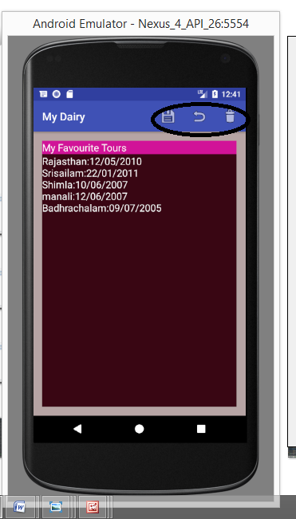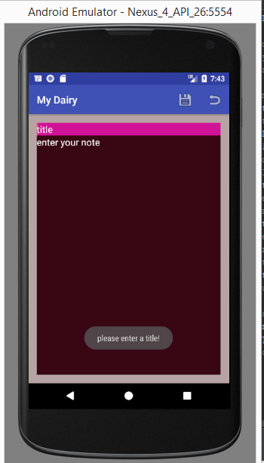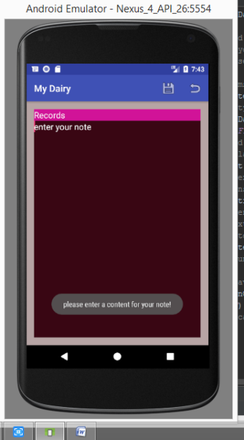

**First Image**:3buttons for editing and saving

Can view or edit and save and back to launcher activity using revert button and delete button can delete saved note

**Second and third image:** without title and content cannot save empty note

d . **Utilities.java** : This java class takes care of saved note and gets all saved notes , and gets saved notes by file name and can delete file and performs File Input output Stream functions saving files and to load back that saved files

e .**DairyAdapter.java**: This class helps to start building the listview which fills the data and displays the data of listview and sets the character length of content

d.DBdairyAdapter.java: This class helps to start building the listview which fills the DB data.

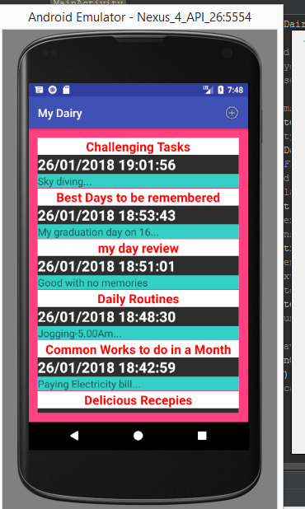

e.DatePickerFragment:This class is to just pick date

f.DBHelper:This class is for inserting data to databseand gets back inserting data

d:NoteListActivity:This class is to display the data in activity_note_list

By using Database the notes will get saved with date selected fro datepicker

Onclicking on save button which was placed in menu_dairy_add the notes will be saved from file and database.

NOTES SAVED FROM FILE : The notes will be saved on clicking on saved button and time was taken default for notes saved from file

NOTES SAVED FROM DATABASE : After writing title and content in activity_dairy select date from date picker and by clicking save button the db notes notes are saved and displays on clicking on view_db_data and displays in activity note list

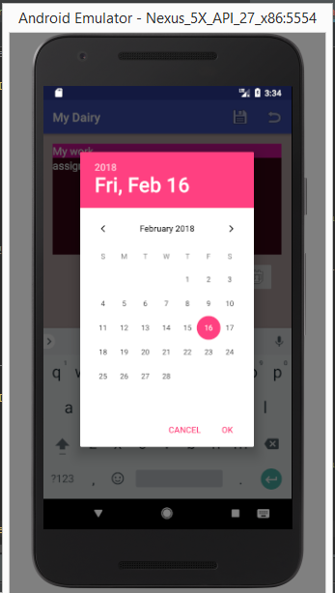

This image is for picking date for dabatabse from date picker

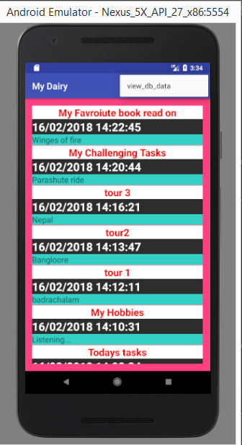 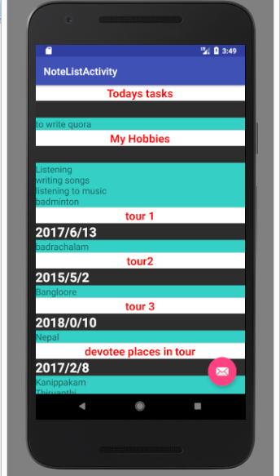

. This image is the notes saved by database are saved in view_db_data which was hidden

Second image is saved notes with no date i.e the date is not taken from date picker and got saved

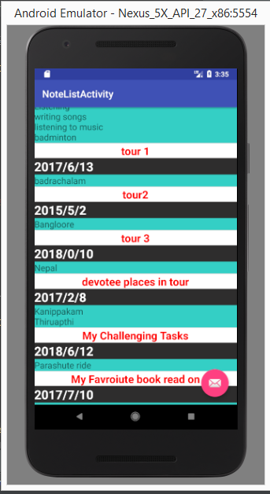

This image is for displaying all saved notes which are saved from database

4**. menu and dialog:**

1. Add button: This menu item is for creating new note

2. Save button: This menu item is for saving the note

3. Saveorupdate button: This menu item is for editing the saved note and to save the note

4. Two revert buttons : one is just for going back to actual activity and another is if any changes are done in saved note after the changes goes back to normal activity

5. Delete button: It can delete the saved note if the note is not necessary

**Dailog :**

1. Two alert dialogs

* If the changes made in note and goes back without saving that it shows popup
* second dialog is for deleting a note

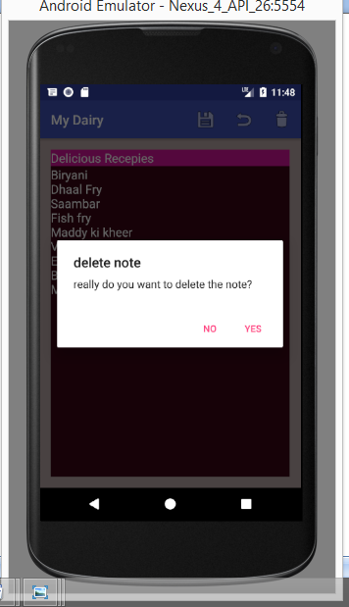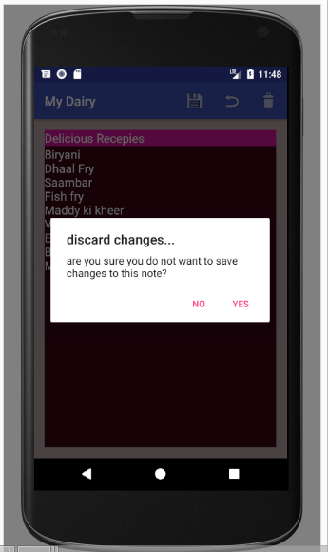

**Conclusion:** Without any complications easily can store our memories with dates and can delete the saved memories or notes , view the saved content using files and can save the notes using database using MyDairy App.

Name : Ch. Tharani

Project Title : MyDairy App

Services Rendered : CoreJava,Android

Environment : Android Studio

(**THARANI CHELUMALLA**)